**Baseline task**

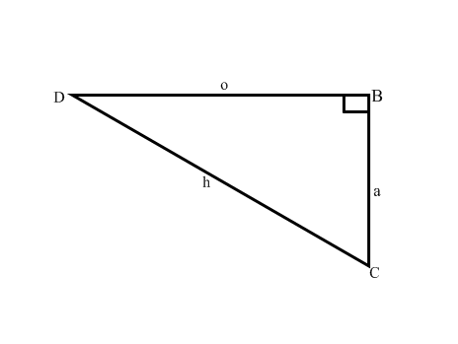The purpose of this task is to assess your knowledge of the grade 10 trigonometry work. Answer the following questions at the back of your 2 quire homework book.

1. Copy and complete the following:
   1. Sin D
   2. Cos D
   3. tan D
2. Use a calculator to find the values of:

2.1

2.2

2.3

3. If  = 15° and ** = 67°, determine using a calculator, the value of:

* 1. cos 2*A*
  2. 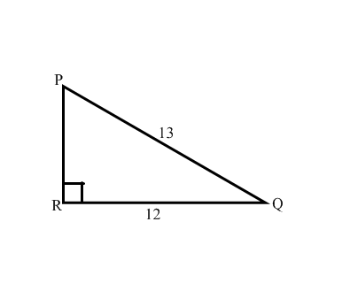 Sin(A+B)

4. In the diagram alongside, find the angle Q.

5. For the diagram below calculate BC.



6. A ladder which is 4m long leans against the wall and makes an angle of ${20}^{0}$ with the wall.

Calculate:

6.1 how high the ladder is above the ground.

6.2 how far the foot of the ladder is from the wall.